Neon Lights Aren’t Dimming, They Are Finding a New Glow
Against the tests of time, the once-widespread form of
lighting has tempered a new niche in society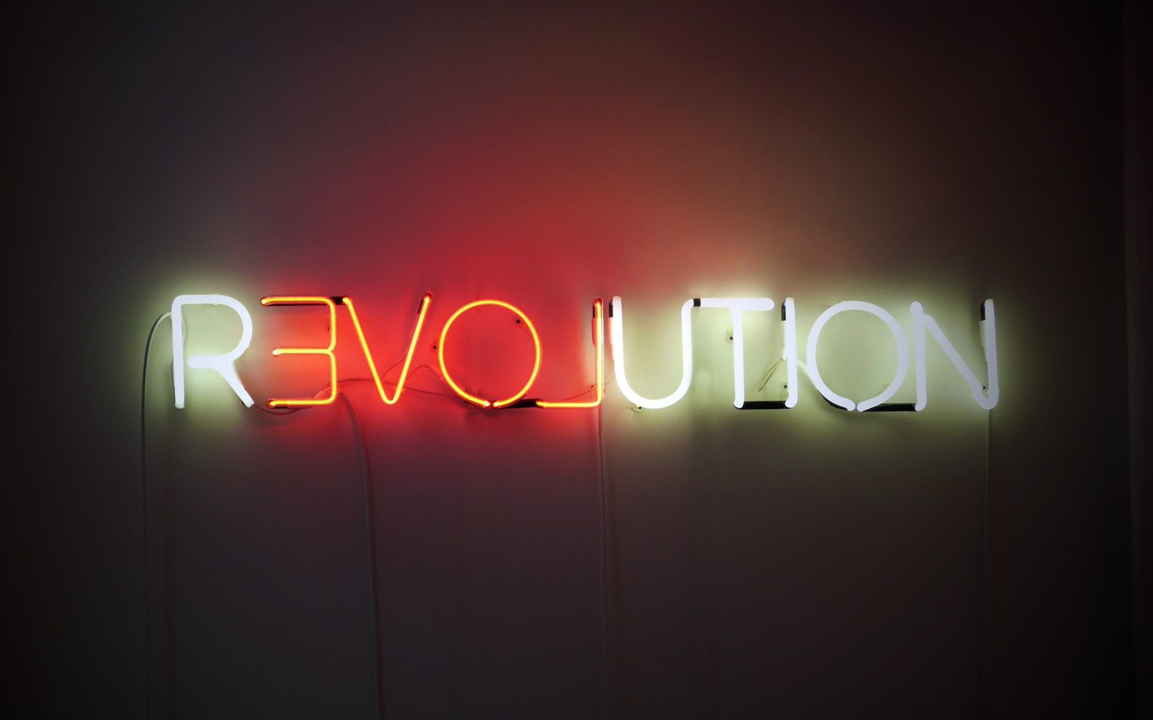
Marc Yanofsky - April 23, 2020
As the world began to enter panic mode and COVID-19 started to become a reality, quicker than anyone could have imagined, I roamed the streets of New York City, experiencing first-hand how the city that never sleeps began to shut down. Shops were starting to close, the streets were feeling empty, and the shelves at Whole Foods were quickly being depleted—not a single potato, pasta box or roll of toilet paper in sight. But as the world seemingly prepared for an apocalypse, a fluorescent pink light caught my eye; undimmed and still hanging from the storefront was a neon pink sign that read “Tacos + Beer”.
There was something so noteworthy about this sign that I just could not get out of my head. I scoured my brain, questioning the nature of neon. From matcha bars to night clubs or the streets of Hong Kong, neon lights illuminate the world around us—it’s uniquely bright and noisy; it’s the familiar crackle of light in old gas stations or the Coors Light beer sign salvaged from the junkyard; it’s a photo opportunity to enhance your Instagram feed or the artsy centerpiece decor of the mansions explored by Architectural Digest—neon lights have come a long way since their conception. I thought to myself: “if the human race were to be wiped out by this pandemic, would the streets of Manhattan stay lit with the glow of neon?”
✺ ✺ ✺
The scientific phenomenon of ‘capturing lightning in a bottle’ is not as avant-garde as one might think, spanning all the way back to the early 1700’s where English scientist and experimentalist Francis Hawksbee sparked the advancement of tube lighting by shaking a vacuum tube filled with mercury (Crowe 30). It wasn’t until the late 1800’s, however, that this practice was standardized by yet another Englishman, Daniel McFarland Moore, who created the Moore tube; the ancient ancestor of the modern neon tube, filled with nitrogen and pumped with electricity to create a fluorescent glow; setting a precedent for glass-shaped electrical signs. However, their popularity, much like their luminosity, did not last for long, crippled by their need for constant maintenance and a short lifespan. But a series of coincidental discoveries of rare gases—helium, argon, krypton, xenon and neon—kept the spark alive for the advancement of neon tube technology (Crowe 31).
Responsible for the neon rush was Georges Claude, an engineer who, in the process of making pure oxygen to fulfill the need of hospitals, derived these rare gasses, but had no clear use for them. Claude experimented with the gases in various ways, many times unsuccessfully, until he came across the Moore tube. By tubing the gases and bombarding them with electricity, Claude discovered the colorful effects produced by the likes of argon and neon (Crowe 31, Osdene 75, et al). Unlike the Moore tube, the new gasses allowed for better light integrity and a much longer lifespan, capable of illuminating city streets in even the worst weather conditions for up to 40 years (Crowe 30). In this way, Georges Claude was successfully able to harness the power of light, “[transforming] the pioneering technological developments of Moore...into a commercially viable endeavor” and in the process, recognizing the boundless advertising potential of neon signage and giving birth to a marketing empire (Osdene 75, 81; Crowe 31).
✺ ✺ ✺
As soon as it reached commercial potential, Neon escaped from its glass casing, spreading to major cities and creating a glow that could be witnessed across the world. Soon after Claude sold the first neon sign intended for commercial purposes in 1912, the neon fever began. By the 1920’s—aided by the leak of patents and trade secrets and the coinciding growth of highway systems—neon radiated through the streets, from Los Angeles to Hong Kong (Crowe 31, Osdene 81, Archer et al).
The neon revolution shone new light (literally and figuratively) onto cityscapes, transforming business fronts and buildings into colorful beacons of light, attracting human capital like mosquitoes. “People often drove for miles to observe the new phenomenon on Main Street,” comments Michael F. Crowe, an architectural historian, in his journal for the Association for Preservation Technology. “By the 1930s virtually every city and town could boast of at least one neon sign.” The scale, brilliance, boldness, and color provided by neon signage revolutionized advertising and marketing; it was a novelty that drove people off roads and created a competition for the largest, brightest, most beautiful sign (Osdene 12, et al).
✺ ✺ ✺
But like any good revolution, the fever faded; people moved on, society adapted, and the nuance took their place. By the 1960’s neon’s fall from grace had already begun, slowly being replaced by the new and cheaper technology of LED lights which promised more versatility, safety, energy efficiency, and lower cost (Brown 41, et al). Many cities once covered in neon lights began to turn their back on their heritage, changing their policies and their attitude; Hong Kong tightened the regulation of public buildings; San Diego required the removal of neon signs with the exception of those regarded as historic; Vancouver even began to vilify neon, categorizing them as intrusive to the cities natural beauty. "They're outsized, outlandish, and—this is the final indignity—blocking our view of some of the greatest scenery in the world," decried Tom Ardies in his 1966 column “Let’s Wake Up from Our Neon Nightmare” for the Vancouver Sun (Crowe 37, Tse 2, Zdanowicz 1, et al). Others heralded neon as overly commercial, “headache-inducing”, and tacky; correlated with “urban decay and red-light districts” (Tse 2).
This has been the narrative of neon since it relinquished its throne of ubiquitous lighting, with conventional wisdom pushing neon signs into the graveyards of Las Vegas and the alleyways of Hong Kong, labeling it as dying art believed to have lost the iconic value it once had in the 20th century. But as people rush to save neon from extinction, scholarly work actually shows that despite its decline, the thirst for neon signs continues, even developing a modern mileage in art, pop culture, and in museums. Furthermore, by observing the evolving usage and social media hype that neon lights have developed on internet platforms, it becomes increasingly evident that not only has neon become an art form reminiscent of the past, but it has in fact become a popular and powerful symbol of the artsy, consumerist, social media-crazed society, retaining its unique capabilities in marketing.
✺ ✺ ✺
Perhaps there is nowhere the fate of neon is more evident than in Hong Kong, where it has transcended its role as a common street object to become a symbol of art and nostalgia. Neon has been immortalized in the region’s image, woven into the fabric of its culture, and enshrined in film. It has created a cinematic universe of dark dense streets illuminated by the soft glow of neon portrayed in Hong Kong films like Fallen Angels, Japanese anime like Ghost in the Shell, and even in Hollywood blockbusters like Blade Runner and Doctor Strange (Sze-Hang Kwok and Coppools 73). But for many the glow of Hong Kong is not on the screen, but rather outside their window or hanging from their shop facade, a city monument, or just the lights of everyday life. “Neon signs are so familiar to people in Hong Kong that, of course, they almost don’t need to think about it.” Aric Chen, the design and architecture curator of M+, Hong Kong’s museum for visual culture, told the New York Times in 2015. (Tse 1).
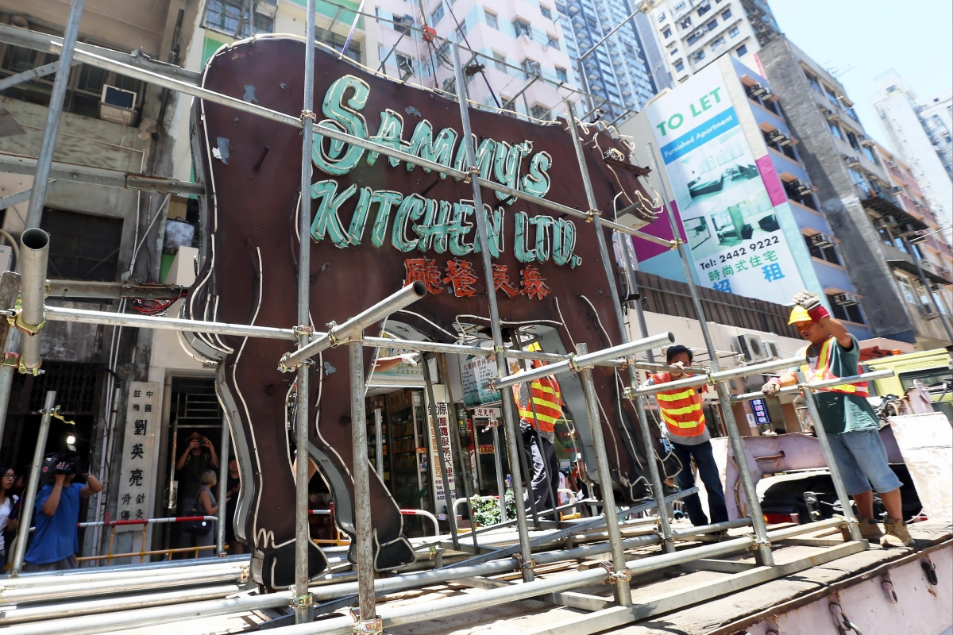
This attitude quickly shifted after Hong Kong’s Building Department stepped in. “For nearly four decades, a giant neon cow suspended above a steakhouse in Hong Kong’s Western District was a neighborhood landmark. It was where, if you were giving directions, you told someone to get off the bus or to take the next left. A glowing bovine beacon nearly 10 feet long and 8 feet tall, cantilevered over the street, you couldn’t miss it” (Tse 1). But in 2015, the Hong Kong government ordered the owners of the sign, Sammy’s Kitchen, to remove the giant cow, leaving the streets feeling “empty” to many such as Iry Yip, the manager of the restaurant (Lou 213, Tse 1). While the owners of the restaurant mourned the removal of the iconic sign that had stood for almost 40 years, the people of Hong Kong and the media rushed to post photos with the cow and reminisce on the monument. Upon its removal, the cow evolved into a symbol much more complex than that of a steakhouse storefront.
According to Dr. Jackie Lou, a lecturer in Sociolinguistics for the City University of Hong Kong, the symbolic power of a monument is derived from an interrelation between visual appearance, location, relationship between the sign and the reader, and, importantly, its place in time. This methodology suggests that after various changes in location and enduring the challenges of time, the sign redefined and recontextualized itself. The sign, now on display in M+, Hong Kong’s museum for visual culture, has transcended its original space in neon discourse and has become even more iconic since its removal. “Detached from the original building, the shop sign no longer indexes the restaurant or the neighborhood, but instead becomes a monument of a bygone era” (Lou 219). This cow now not only symbolizes Hong Kong's neon heritage, but in my opinion, it symbolizes the journey of neon around our world, versatile in its recontextualization across time and culture.
✺ ✺ ✺
To further this idea of recontextualization and the contrasting effects time and culture can have on neon’s representation, consider the Soviet Union, for example. As the world’s neon population was invaded by LED’s in the 1960’s, the Soviet Union was only beginning its ‘neonization,’ attempting to parallel the capitalist metropoles of their rival nations (Miranda). At the same time, urban lifestyles in the US experienced a drastic shift as the “aggressive pursuit of cultural capital” ravaged through society, creating changes in consumerist culture such as the aestheticization of space, a new focus on visually-oriented consumerism, and the emergence of postmodernism in art (Zukin 825). Alongside these cultural changes was neon, the light at the heart of the most commercially potent cities; from Times Square in New York City to the Strip of Las Vegas. In the process, it earned an image related to booze, dancing, and gambleing; the widespread wave of neon eventually “fell prey to the cultural and economic dynamics of urban renewal” (Osdene 187).
But as darkness seemed to set on the signage, American neon simultaneously began to develop its place in art thanks to pioneers of minimalism and conceptualism like Dan Flavin, Bruce Nauman, and Glenn Ligon. These artists helped neon quickly overcome its image of sex shops and sordid motels and rebrand its image, entering the most prestigious museums; Guggenheim, MOMA, Smithsonian American Art Museum, Tate Modern, Pompidou, even eventually establishing its own Neon Museums in LA and Las Vegas; and solidifying itself as a legitimate sculptural medium (Osdene 193, Archer, Wallace, et al).
Yet popular media publications like the New York Times and CNN still headline neon as “dying” or “dimming,” with many rushing to “save” it (Zdanowicz 1, Tse 1, et al). But how could this be? Although it may be true that neon is far from the omnipresent power it once was, it’s unfair to push it towards extinction. Neon has never been dying. Instead, it has slowly been adapting to the changes that come naturally with time, tempering its glass to fit into society.
It may even be fair to claim that neon will never die, as it holds a unique and unmatched influence as a marketing machine, even for itself. Carol Pui-Ha Chow, lecturer and researcher at the Chinese University of Hong Kong, pushes a theory that extends the discourse of how cultural capital and the use of linguistic signs and image contributes to the space of economy, referred to as ‘image capital.’ Chow observes the relationship between culture and the economy as a dynamic one; a simultaneous force that influences our social sphere, while applying ideals of semiotics and consumerism. She argues that image is an important resource in the capitalist venture for money and that incorporating signs in the space of economy is a powerful tool for commercial endeavors (Chow 251-252). Most importantly, Chow argues that “aesthetic symbols have acquired a new life through the engine of media,” extending their capabilities as visual advertisements (Chow 263, 268).
Theoretically, this concept of image capital should parallel the story of neon signs, as neon serves as a sign and, at times, an image too; and if she is correct, the next step in its history would not be a slow and painful death, but rather a resurrection through media.
✺ ✺ ✺
While old neon signs from the early century ended their 40-year lifespan with urban decay, a new generation has emerged. Neon created a new niche centered around nostalgia and propelled by artsy consumerist culture.
“Neon signage can be thought of as something of an anomaly in that it dually relies upon artistry and an unwavering commitment to commercial aims. Few other advertising mediums embody these seemingly contradictory dynamics,” writes Stefen Osdene in his dissertation “American Neon Signs: Illumination And Consumerism.” “This underlying tension, I argue, has been one of the most important factors in neon signage’s continuing life cycle. Its niche role as something that straddles the realms of commerce and artistry has made it one of this country’s most bombastic and diverse forms of advertising.” (Osdene 211)
To this day, neon still offers these benefits. Although some question neon’s potential for reproduction, a crafting process that takes a lot of skill and time, neon shops have popped up all over the US. Just this past February, Good Morning America featured a New York City-based neon studio NAME GLO, who’s owners say their business has been “catapulted” by social media, eclipsing 25 thousand followers on Instagram. Neon fame on the internet is not limited to this store, however, with thousands of listings on Etsy for cheap custom made signs, millions of Instagram posts tagged with #neon, and miniature neon sculptures being sold by Urban Outfitters and other retailers. New restaurants and shops have identified this trend, adding neon to their store’s aesthetic, creating a photo opportunity for their social-media crazed customers, and realizing the value of experiential marketing. Neon has even inspired a music festival in El Paso, the Neon Desert Music Festival, drawing popular EDM and rap artists like Steve Aoki, Lil Wayne and Wiz Khalifa to headline the show. Against the odds of literal rusting and symbolic deterioration, neon has once again displayed that its nature is as flexible as its physical form, perduring through changing scenes and consistently recontextualizing itself as a cultural force. The question now is how long can neon withstand the test of time? And if the human race were to be wiped out, would the world stay lit with the glow of neon?

Works Cited:
Archer, Sarah. “Neon Is the Ultimate Symbol of the 20th Century.” The Atlantic, Atlantic Media Company, 30 Apr. 2019, www.theatlantic.com/entertainment/archive/2019/04/being-and-neonness-neon-lights-symbol-20th-century/588184/.
Chow, Carol Pui-Ha. “Image Capital, Field, and the Economies of Signs and Space.” The Communication Review, vol. 16, no. 4, Routledge, Oct. 2013, pp. 251–70, doi:10.1080/10714421.2013.839596.
Crowe, Michael F. “Neon Signs: Their Origin, Use, and Maintenance.” APT Bulletin: The Journal of Preservation Technology, vol. 23, no. 2, 1991, pp. 30–37. JSTOR, www.jstor.org/stable/1504382.
Good Morning America. “Neon for the Age of Social Media: Here's How It's Made.” Good Morning America, www.goodmorningamerica.com/living/story/neon-age-social-media-made-68569177.
“Iconic Neon Cow Sign in Hong Kong Removed, Set for New Museum.” South China Morning Post, 6 Aug. 2015, www.scmp.com/news/hong-kong/health-environment/article/1846810/iconic-neon-cow-sign-hong-kong-removed-set-new.
“Image of Revolution 1.” Pinterest, www.pinterest.com/pin/858569116435844510/.
Lou, Jackie. “Shop Sign as Monument: The Discursive Recontextualization of a Neon Sign.” Linguistic Landscape, vol. 2, no. 3, John Benjamins Publishing Company, Jan. 2016, pp. 211–222, doi:10.1075/ll.2.3.01lou.
Miranda, Luis de, and Michael Wells. Being & Neonness. MIT Press, 2019.
Romeyn, Kathryn. “An Artful Neon Spectacular in This Black L.A. Home.” Architectural Digest, Architectural Digest, 18 Apr. 2019, www.architecturaldigest.com/story/beth-redmond-la-home.
Sze-Hang Kwok, Brian, and Anneke Coppoolse. “Hong Kong Skins: Signs and Screens in a Changing Cityscape.” Visual Communication, vol. 17, no. 1, SAGE Publications, Feb. 2018, pp. 71–90, doi:10.1177/1470357217723210.
Tse, Crystal. “Hong Kong Is Slowly Dimming Its Neon Glow.” The New York Times, 13 Oct. 2015, www.nytimes.com/2015/10/14/world/asia/hong-kong-neon-sign-maker.html.
Wallace, Hal. “OPEN: The History of Neon Signs.” The Atlantic, Atlantic Media Company, 20 Apr. 2012, www.theatlantic.com/technology/archive/2012/04/open-the-history-of-neon-signs/256145/.
Zdanowicz, Christina. “Neon Signs Are Dying, but Our Appreciation Isn't.” CNN, Cable News Network, 25 July 2014, www.cnn.com/travel/article/neon-signs-dying-irpt/index.html.
Zukin, Sharon. “Urban Lifestyles: Diversity and Standardisation in Spaces of Consumption.” Urban Studies, vol. 35, no. 5-6, Sage Publications, May 1998, pp. 825–839, doi:10.1080/0042098984574.

